Problem 1
Determine the z-transforms of the following signals including the Region of Convergence (ROC) and sketch the corresponding pole-zero plot. In the solution, you can use the z-transform pairs and properties tables:

Solution:

ROC: Entire z-plane except at z = 0 and z = ∞
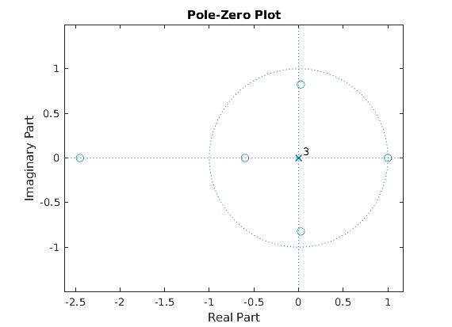

ROC: Entire z-plane except at z = 0

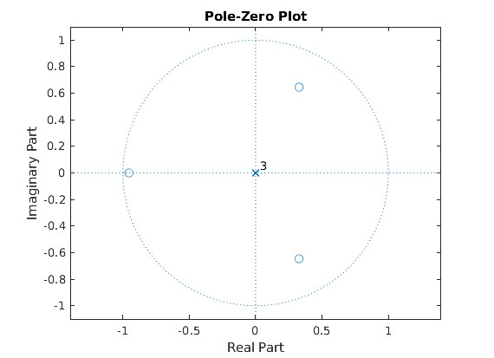

ROC: Entire z-plane except at z = 0 and z = 1/5
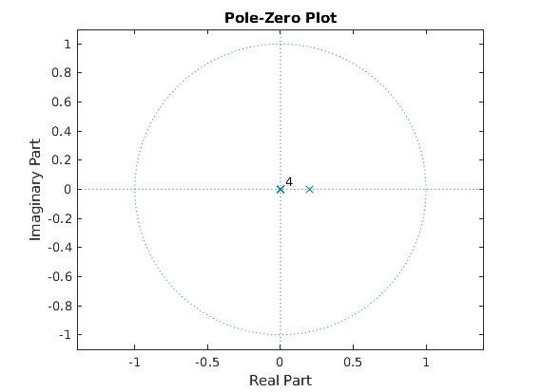

ROC: Entire z-plane
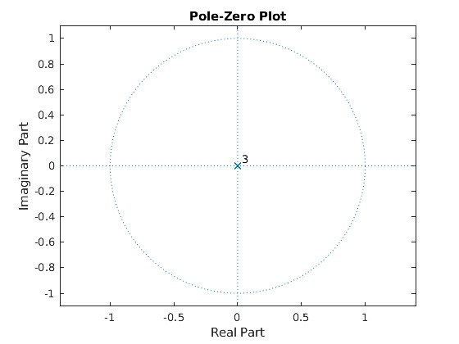

The z-transform does not exist.

Problem 2
Determine the causal system that corresponds to the following z-transforms:

Solution:
- Inverse Z-Transform: Distinct Poles
First, we eliminate the negative powers, by multiplying both numerator and denominator by z²

To find the roots of the denominator, we use the formula

Therefore,
(1)
We now need to express this in the form
(2)
To find A₁ and A₂, we express equation (2) as (1) again and compare the coefficients
(3)
Comparing the coefficients of the numerator of (3) to (1), we get that

Solving the last 2 equations together, we get

Therefore, X(z)/z can be written as

By using the z-transform pairs table, and given that the signal is causal we get

- Inverse Z-Transform: Multiple-order Poles
First, we eliminate the negative powers, by multiplying both numerator and denominator by z⁹

To find the roots of the denominator, we use the formula

Therefore,
(1)
We now need to express this in the form
(2)
To find A₁, A₂, A₃, A₄, A₅, A₆, A₇, A₈, and A₉, we express equation (2) as (1) again and compare the coefficients
(3)
Comparing the coefficients of the numerator of (3) to (1), we get that

Solving the 9 equations together, we get

Therefore,

By using the z-transform pairs table, we get

- Inverse Z-Transform: Multiple-order Poles
First, we eliminate the negative powers by multiplying both the numerator and denominator by z⁶

Therefore,
(1)
We now need to express this in the form
(2)
To find A₁, A₂, A₃, A₄, A₅, and A₆ we express equation (2) as (1) again and compare the coefficients

Solving the 6 equations together, we get

Therefore,

By using the z-transform pairs table, we get

Problem 3
For each of the systems defined by their impulse response function below, find the output of the system in response to the given input:

Solution:
- First, we need to get the z-transform of the system equation

Therefore,

By using the z-transform pairs table, and given that the signal is causal we get

- First, we need to get the z-transform of the system equation

Therefore a pole-zero cancellation occurs,

Inverse Z-Transform: Improper Rational
Long Division
Since the order of the remainder polynomial is less than the polynomial we are dividing by, we stop

The inverse z-transform can be then written as

First, we eliminate the negative powers by multiplying both the numerator and denominator by z²

Then
(1)
We now need to express this in the form
(2)
To find A₁, A₂, and A₃, we express equation (2) as (1) again and compare the coefficients
(3)
Comparing the coefficients of the numerator of (3) to (1), we get

Solving the 2 equations together, we get

Therefore, M(z)/z can be written as

By using the z-transform pairs table, and given that the signal is causal we get

- First, we get the z-Transform of the system equation

Therefore,

Inverse Z-Transform: Improper Rational
Long Division
Since the order of the remainder polynomial is less than the polynomial we are dividing by, we stop
The inverse z-transform can be then written as

Then
(1)
We now need to express this in the form
(2)
To find A₁, A₂, and A₃, we express equation (2) as (1) again and compare the coefficients
(3)
Comparing the coefficients of the numerator of (3) to (1), we get

Solving the last 3 equations together, we get

Therefore, M(z)/z can be written as

By using the z-transform pairs table, and given that the signal is causal we get

Problem 4
Implement the following function using MATLAB or Python:
ExponentialMovingAverageFilter: A function that takes as input the file name of an input audio file, the moving average window size M, the parameter a, and the file name of the output filtered audio file. This function should convolve the exponential moving average filter with the input signal. The impulse response of the exponential moving average filter takes the form

where M = 2L + 1.
To adjust for the attenuation that occurs after filtering, scale the output obtained after filtering to have the same maximum value as the input audio.
Deliverables:
- Your code (either MATLAB .m files or Python .py files or Jupyter notebook files).
- Apply the implemented function to the audio file provided “NoisyTone.wav” using a = 0, a = 0.25, a = 0.9. In all cases, use M = 201. Name the output audio files “Filtered_a_0.wav”, “Filtered_a_0_25.wav”, “Filtered_a_0_9.wav”, respectively. The sampling rate of the original audio is 10 KHz.
- The file “CleanTone.wav” includes the same audio without noise. Plot the first 1000 samples of the clean tone, the noisy tone and each of the 3 filtered signals obtained in (ii). Comment on the quality of the output obtained in (ii) relative to the clean tone based on the figure.
- Apply the implemented function to the audio provided “NoisyTone.wav” using M = 3, M = 30, and M = 50. In all cases, use a = 0.25. Name the output audio files “Filtered_M_3.wav”, “Filtered_M_30.wav”, and “Filtered_M_50.wav”, respectively.
- Comment on the impact of increasing M on the quality of the filtered output obtained in (iv).
Solution:

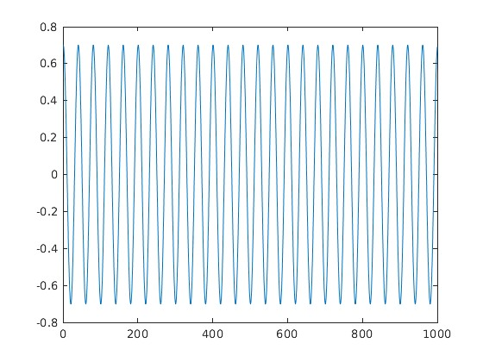

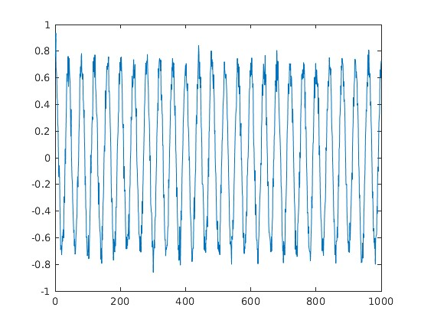

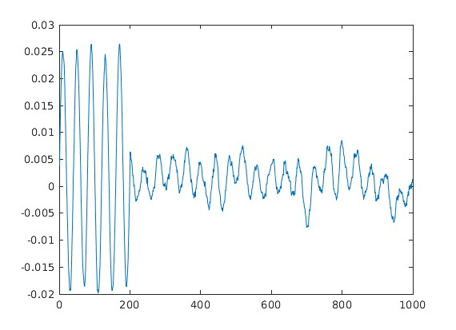

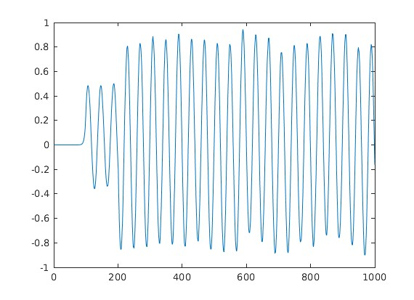

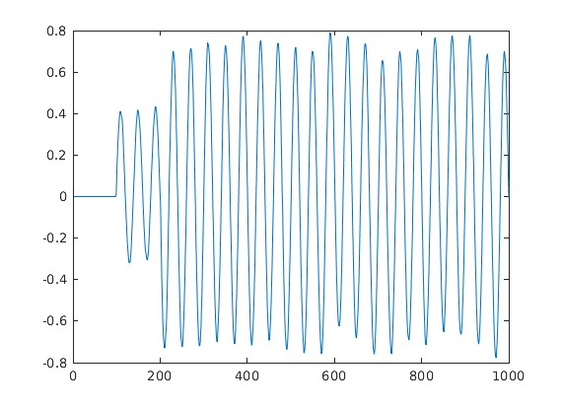

Based on the figure, the quality of the output obtained in (ii) is lower than the quality of the clean tone. However, the quality of the output obtained in (ii) when a = 0.25 was closest to the quality of the clean tone.
The impact of increasing M is an increase in the quality of the filtered output obtained in (iii).
Important Notes:
- All deliverables should be included in one .zip file.
- For Problems 1, 2 and 3, scanned version of handwritten solutions is acceptable.
- For Problem 4, you can use the convolution function available in MATLAB or Python to apply the filter to the input audio. Don’t use ready made functions that you might find available in MATLAB or Python that directly implement the Exponential Moving Average Filter.
- This is an individual assignment.

